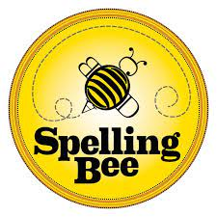

SPELLING BEE CONTEST

**WORD BANK:**

|  |  |  |
| --- | --- | --- |
| N° | **VOCABULARY** | **PRONUNCIATION** |
| 1.- | boots | /buts/ |
| 2.- | coat | /kóut/ |
| 3.- | gloves | /glóubs/ |
| 4.- | hat | /ját/ |
| 5.- | raincoat | /réinkout/ |
| 6.- | scarf | /skarf/ |
| 7.- | shoes | /shus/ |
| 8.- | sweater | /swérer/ |
| 9.- | clothes | /klóuds/ |
| 10.- | accessories | /áksesoris/ |
| 11.- | lunchbox | /lónch box/ |
| 12.- | bracelet | /bréiselet/ |
| 13.- | umbrella | /ambrela/ |
| 14.- | stickers | /stíkers/ |
| 15.- | sunglasses | /sánglases/ |
| 16.- | Key chain | /ki chein/ |
| 17.- | Wake up | /wéik ap/ |
| 18.- | Brush your teeth | /brash ior tiit/ |
| 19.- | Take a shower | /teik a shauer/ |
| 20.- | Get dressed | /guet dres/ |
| 21.- | Put on your shoes | /púron ior shus/ |
| 22.- | Brush your hair | /brash ior jer/ |
| 23.- | Wash your hands | /wash ior jends/ |
| 24.- | Dry your hands | /drai ior jends/ |
| 25.- | morning | /mornin/ |
| 26.- | routine | /rutín/ |
| 27.- | toothbrush | /tútbrash/ |
| 28.- | Hair brush | /jerbrash/ |
| 29.- | toothpaste | /tútpeits/ |
| 30.- | comb | /komb/ |
| 31.- | soap | /soup/ |
| 32.- | shampoo | /shémpu/ |
| 33.- | professions | /proféshons/ |
| 34.- | workplace | /workpleis/ |
| 35.- | airport | /érport/ |
| 36.- | clinic | /klínic/ |
| 37.- | Fire station | /fáyer steishon/ |
| 38.- | office | /ófis/ |
| 39.- | Police station | /polís steishon/ |
| 40.- | restaurant | /rréstorant/ |
| 41.- | theater | /zírer/ |
| 42.- | scientist | /sáientist/ |
| 43.- | firefighter | /fáier fáirer/ |
| 44.- | Police officer | /polis óficer/ |
| 45.- | secretary | /sékretari/ |
| 46.- | Take care | /téik ker/ |
| 47.- | Do experiments | /du expériments/ |
| 48.- | Collect coins | /kolect coins/ |
| 49.- | Do gymnastic | /du yímnastik/ |
| 50.- | Go shopping | /gou shopin/ |

3rd grade

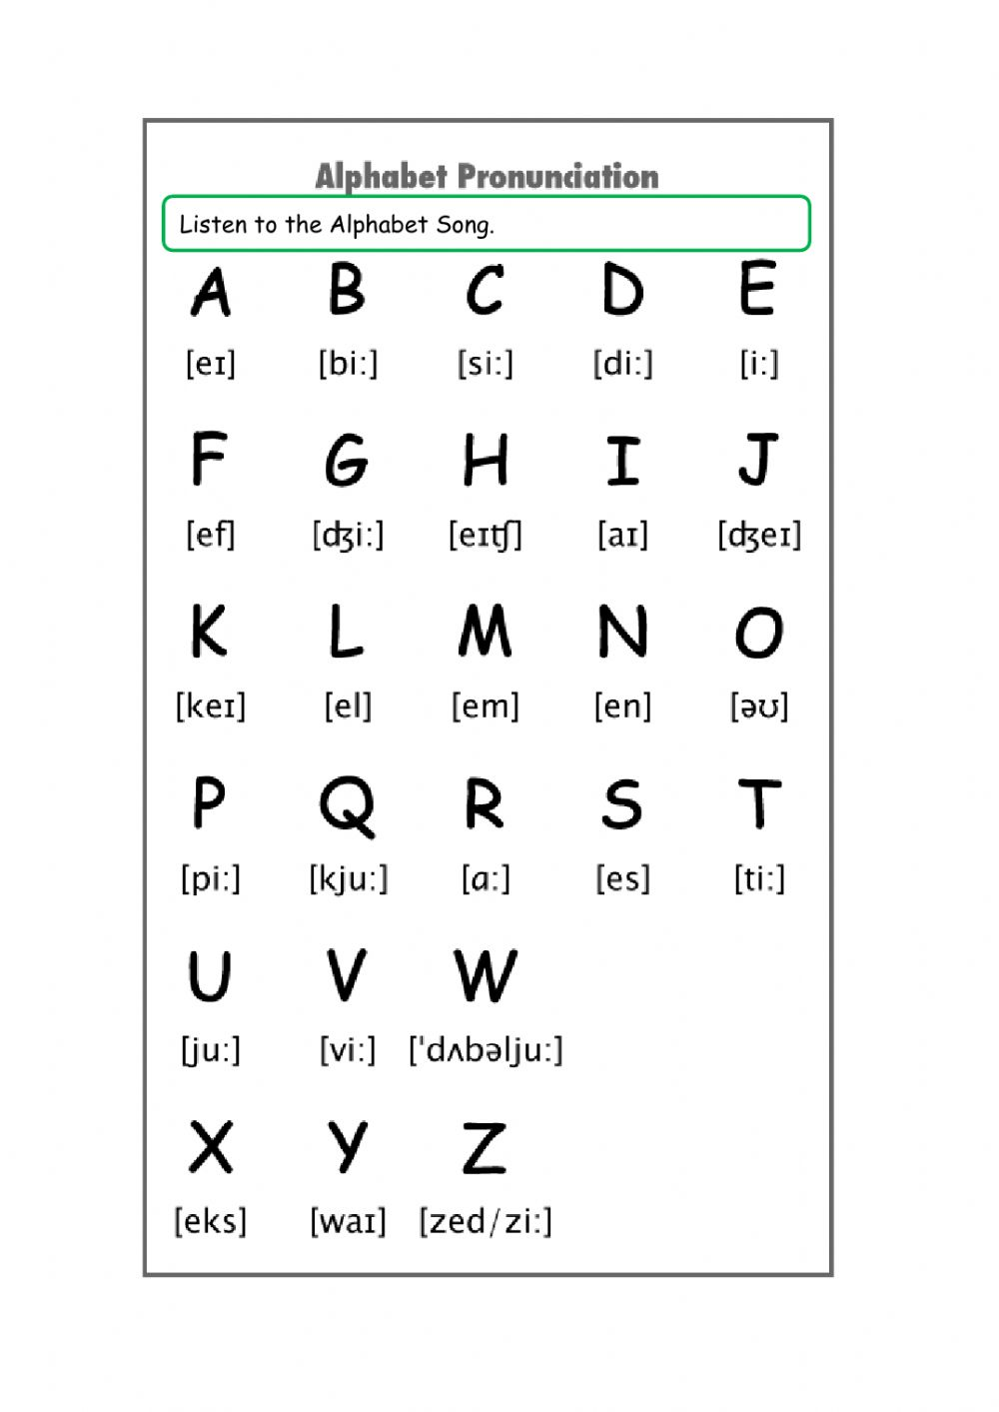

The alphabet

[zii]

[iu]

[dávolyu]

[ar]

[kiu]

[ou]

[llí]

[yéi]

[éich]

**Practice the Pronunciation:** (practica la pronunciación)